 St Mark’s Pre-School Newsletter
This Terms April 2025
Activities

Our first topic was Pirates and Under the Sea. We had some tricky yoga poses to do this week that really got us balancing and stretching. In the tray we had a treasure map and some treasure chests, we had to try and find the X marks the spot on the map and that would lead us to the golden treasure! On the creative table we used our imagination and made some jellyfish and other under the sea animals using paper plates and blue strips of paper for the tentacles, we used some glue to stick these on and spoke about if the tentacles were long or short. In the maths area we had some new sea animal colour sorting. We had to use tweezers to pick up the animals and put them in the correct coloured bowl, this was great for our fine motor skills and helped us with colour recognition too. In the literacy area we worked on pencil grips and letter formation by tracing some under the sea letters. In the tuft tray we used our imagination with the Barbies and their very special mermaid tails to do some story telling. On the large carpet area, we had a pirate’s plank! We had to use our balancing skills to get across it because if we fell in, we didn’t want to get eaten by a shark!
At the end of the week, we celebrated Red Nose Day and we had a very fun Pyjama Party! We also managed to do a spot of karaoke too. We all thought it was very funny to come to pre-school in our pyjamas.

We then moved onto our Spring topic. On the literacy table we have been doing a Spring dot to dot but instead of numbers it is the alphabet, this has been helping with our letter recognition and again with our pencil grip and control. In the tuft spot we have had colanders and been poking flowers through the small holes helping with our fine motor movements. On the creative table we have been working on our cutting skills and cutting bits of coloured paper to make some tulips. On the maths table we have been working on our numbers, and we had a Spring number matching activity. On the easel we have had some Spring pictures and paint, some of the children have been mixing the paint to make a new colour!
We also had a lovely Mother’s Day stay and play session celebrating our Mummies and some grandmothers too, we even had time for a yummy cream tea.

We would like to wish everyone a lovely Easter half term.

Can we please remind parents not to talk with the member of staff at the door in the mornings, they are required to make sure all children remain within the setting and to ensure their safety. If you need to speak with a member of staff, please feel free to approach another member of the team.

illness

We have found this term there has been a lot of children attending Pre-School when unwell. While it’s okay for children to attend with a slight cold or cough, we are asking that children are to stay at home if they have a constant cough, unwell in themself or their nose is constantly streaming with thick green snot as this is a sign of infection! Please see the picture below.

While it’s lovely to hear that although your child is poorly, they want to come in because we are doing something fun on this day, please make this decision yourself based on how you think they are feeling and if they will cope throughout the morning/day, as well as passing on whatever they have onto others, thank you.

Children are not to attend Pre-School if they have had Calpol,
we can’t stress this enough as we try to limit the bugs from spreading!

Could we also please ask that you let us know in the morning if your child is not coming in and why, this could be a text or a phone call.

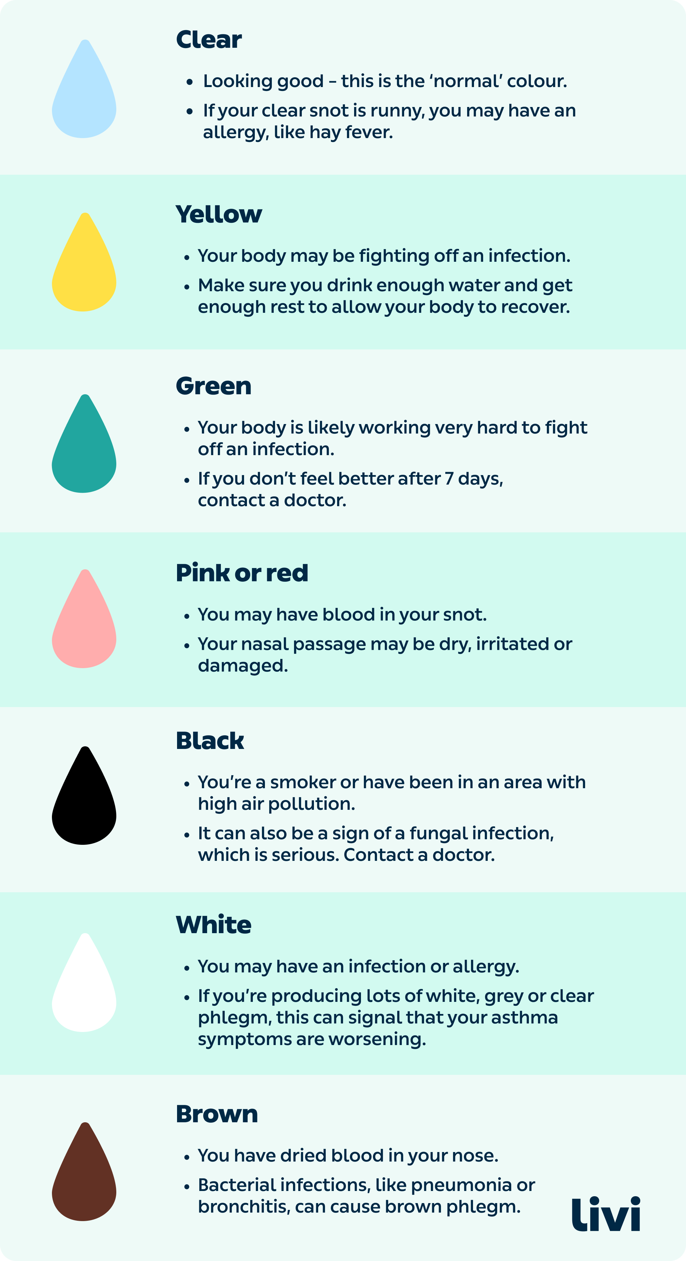

Easter Bonnets

We will be holding our annual Easter Bonnet competition again this year. Over the Easter half term, we would love the children to make an Easter Bonnet and bring it in the week that we return, there will be a small prize for the winner.

Get creative and have fun!

Labelling

Could we please remind all parents to label their child’s clothes. This will make it much easier to make sure your child goes home with the correct items, especially as now many of them are wearing the same Pre-School tops and jumpers.

Half Term Topics

This half terms topics will be.

Week 1 – 22/04/25- Easter
Week 2 – 28/04/25 – On the farm
Week 3 – 05/05/25 – On the farm
Week 4 – 12/05/25 – Growing and life cycles
Week 5 – 19/05/25 – Growing and life cycles

30 Hour Funding

In September 2025, 15 hours for working families with children under 3 will expand to 30 hours, meaning eligible working families will be able to claim 30 hours of childcare from the term after their child turns 9 months until they reach school age.

If you are unsure whether you are able to apply you can use the childcare calculator on the childcare choice’s website.

www.childcarechoices.gov.uk

Once you have received your code, please give this to Lorraine.

Tuesday Forest School

All children need to bring in their own forest school backpack. This backpack needs to be big enough for the children to have a complete change of clothes, (top/bottoms/pants/socks) nappies and a spare set of waterproofs in, but small enough that they are able to carry it. They will also require a small named water bottle to go in this backpack.

All children joining us for lunch will need to bring a packed lunch with an additional drink and ice pack. Drop off and collection for both 12pm and 2:45pm will be from the cricket club.

Can we please ask that you let the teachers partner up the children for the walk into the forest, they are partnered up on age and ability following a pre-organised list. The children can find it upsetting if they are moved after parents have let them choose who’s hand they would like to hold.
Thank you.

Forest School Summer Kit

Now the weather is becoming warmer I would like to give you the kit list for our forest school sessions.

Please remember to dress your child accordingly for the forest. The summer kit list is as follows:

*Long sleeve top
*Leggings/jeans/ trousers
*Waterproofs – if it has or is raining
*Wellies if wet, trainers if not
*Light jacket
*Sunhat
Please remember if it is a bit colder your children will need extra layers to keep warm.

Please don’t forget to apply insect repellent to your children.
Please check for your child for ticks after each forest school sessions. Ticks are small, spider-like creatures that live in woods and long grass. They are not something we can check for when we enter the forest. They attach themselves to skin that brushes past them. A tick bites into the skin and feeds on blood before dropping off a few days later.
Ticks can cause Lyme disease, which is a bacterial infection that can be spread to humans by infected ticks. Some people suffer with flu like symptoms in the early stages of the disease. These include: a high temperature or feeling hot and shivery, headaches, muscle and joint pain and tiredness and loss of energy. Not everyone with Lyme disease gets the rash.

For more information on Lyme disease please visit https://www.nhs.uk/conditions/lyme-disease/

Pick Up

Please can we ask parents when picking their children up when at the hall that you do not allow your children to run in the graveyard and over the graves! Unfortunately, we have had a couple of complaints about this, these are peoples loved ones and this needs to be respected. We understand that in some areas there is a path but as we know children don’t always stick to these!
Could we also ask that parents don’t allow their children to run around the side of the building, both sides are used as exit points, and we have had a few near misses of children running around the side and nearly bumping into children leaving.

Reminders

We have noticed some parents are picking up their children late, can we please ask that parents are ready to collect their children from either 12pm or 2.45pm, otherwise you will incur a late fee surcharge of £5.00 as per our Terms & Conditions within your contracts.
We appreciate that sometimes this can’t be helped, so we just ask that you please call us and let us know.

For those children who take part in our Forest school session and who wear wellies, please make sure you add either thick ski socks or fleecy welly boot liners or both to keep your child’s feet warm.

Also, a reminder that we will be leaving for the Forest promptly at 9am, If you are running late and not there or ready to leave unfortunately you will need to walk your child over to us in the forest. The longer we are waiting at the cricket car park for children to arrive is upsetting for the children already there and waiting to go.

Activities at Home Box

This box will be available every morning for you to choose an activity to share with your child at home. Please fill in the book to sign in and out your activity.

Internet Safety

Online safety advice More and more pre-schoolers are using their parents’ computers, smartphones or tablets to play games, use apps, and watch their favourite TV shows. There are simple things you can do to make sure they’re using the internet safely. Copy and paste the following link for further online safety advice. www.internetmatters.org

Working in Partnership with Parents

We would like to thank all the parents who log in, makes comments and add their own observations onto tapestry. We value our partnership with parents and this is a wonderful tool to enable us to do this. These home observations give us a chance to see things we are unable to observe within pre-school and provides great topics of conversation between your children and all the staff. We hope that you enjoy seeing what your children do during their time day and this is also a wonderful keepsake of their journey with us which you will keep once they move on from Pre-School.

Operation Encompass

St Mark’s Pre-School have taken the opportunity to join the Operation Encompass scheme which will run jointly between local early years settings, schools, Surrey Police and Surrey County Council. Operation Encompass has been designed to provide early reporting on any domestic incidents that occur outside of ‘normal’ school hours and might have an impact on a child in their setting. Operation Encompass will ensure that the settings’ Designated Safeguarding Lead (DSL) or deputy DSL, is informed the next morning that there has been a domestic incident or if a child has been reported as missing. Through sharing this information with the DSL and/or deputy DSL the setting can ensure that the child/ren are supported in the most appropriate way. For more information click here.

Mrs. Odam’s Fortnightly Challenge

Every fortnight Mrs Odam will be setting an exciting challenge for you and your child to complete at home.
The challenge will be uploaded onto tapestry every other Monday and we would love for you to add your pictures and comments onto tapestry any time before the next challenge is set, so we can see how well you have done.
We believe this will be a great way to gain stronger links between Pre-School and home and involving parents within their child’s learning and development.

Show and Tell Table
The children very much enjoy bringing items in from home to share with their friends at the end of the session. This is a great way for the children to listen to others and share what they have, building speech and language development. The show and tell table is the red table, located at the front of hall by the main entrance. We ask that items being bought in are theme related or something special, for example if they have had a birthday or been somewhere for a visit or an achievement such as a certificate or badge. The themes can be found on the first page of the newsletter under what we have been learning about. The themes are also always displayed on the poster above the table and changed weekly if your child is unsure of what they can bring.

Proud Clouds
Our children all love to achieve new things. At Pre-School we want to hear all about it too! Proud clouds are shared with everyone at the end of the session. Proud clouds are a chance for you to share what your child has achieved i.e., learning to count, riding a bike, becoming independent in getting dressed. These are all massive achievements, and we want to share it. If your child has done something amazing, please write it down on a coloured shape which can be found on the parents table and give it to a member of staff. Once it has been read out it will be attached to our proud clouds which can be found on the garden door windows. Please ask if you have any questions about proud clouds.

Consumables

From April we will be changing how we charge for the Consumables contribution.
This will now be charged at 68p per each hour that your child does with us; the cost will cover items such as;

Wipes
Nappies
Additional snack / Milk
Tissues
Arts & Crafts

Fees

From April 2025 our fees will be increasing in line with inflation.
2yr old, 3hr session - £26.76
2yr old, full day session - £51.29
3yr old, Top up of funded hours - £7.40 p/h

Bags and Welly Boots

Please remember to bring a bag in for your child with a full spare set of clothes in, to be left on the trolley in the foyer area. Please also remember to bring in welly boots on the days your children attend. The children are encouraged to be independent in their dressing so shoes with Velcro rather than laces please.

Book Bags

Every two weeks the children will be able to choose a book to bring home and share with you. Once your child has finished their book you can bring back their book bags and place them in to their keyworkers box. This is a great way for the children to share stories with you and encourages the joy for reading.

Oral Health

As part of the early years’ foundation stage (EYFS, 2021) we are required to support oral health.

A regular teeth cleaning routine is essential for good dental health. Follow these tips and you can help keep your child’s teeth healthy.

Children's teeth - NHS (www.nhs.uk)

Healthy Lunchboxes

We ask parents to provide a piece of fruit for snack time, please make sure this is labelled. We will provide additional snack such as toast, flatbread and crumpets etc. as well as water or milk to drink. We ask parents if their child brings grapes for lunch or snack, they need to be cut in half length ways and not left whole or cut width ways. Grapes are the perfect size to block a child’s windpipe and pose a choking hazard.

Lunches, please ensure that your child’s lunch box is also a healthy one, please, no big bars of chocolate, sweets or fizzy drinks. Please could we ask that the food in your child’s lunch box is healthy and has good nutritional value to it.

For example: A sandwich/wrap/roll with nutritional filling i.e., cheese, ham, chicken etc. Or pasta. A piece of fruit / vegetable sticks Yoghurt / cheese Crisps / popcorn, small treat

We want to promote a good varied diet with our children but following the Healthy Lunch Box values which the schools also adept. As a reminder, please no large bars of chocolate, large chocolate biscuits, sweets or fizzy drinks.

For ideas of lunchbox ideas please visit

www.nhs.uk/change4life/recipes/healthier-lunchboxes

Facebook Page

Please take a look and like our Facebook Page (St Mark’s Pre-School) to receive daily/weekly notices, diary dates and also to find out what we have been doing with your children throughout the week.
St Mark's Pre-School | Facebook




- Wednesday 2nd April – Last day of term
- Thursday 3rd April – Teacher training day
- Tuesday 22nd April – First day of term
- Wednesday 23rd April and Thursday 24th April – Easter bonnet competition
- 5th May – Bank holiday




Keep up-to-date with the latest information, diary dates, Forest School sessions and more, on our Website and Facebook page;

www.stmarkspreschool.info

